GITHUB LINK - https://github.com/FoolishAmbition/inf1103-labs
Screenshots - 4. Docker Mount and Run
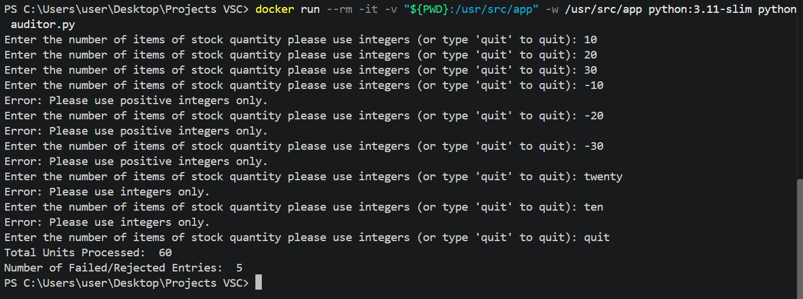
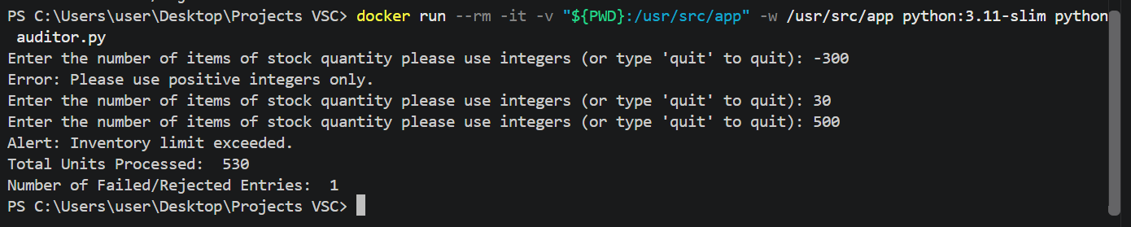

Screenshots – building custom image
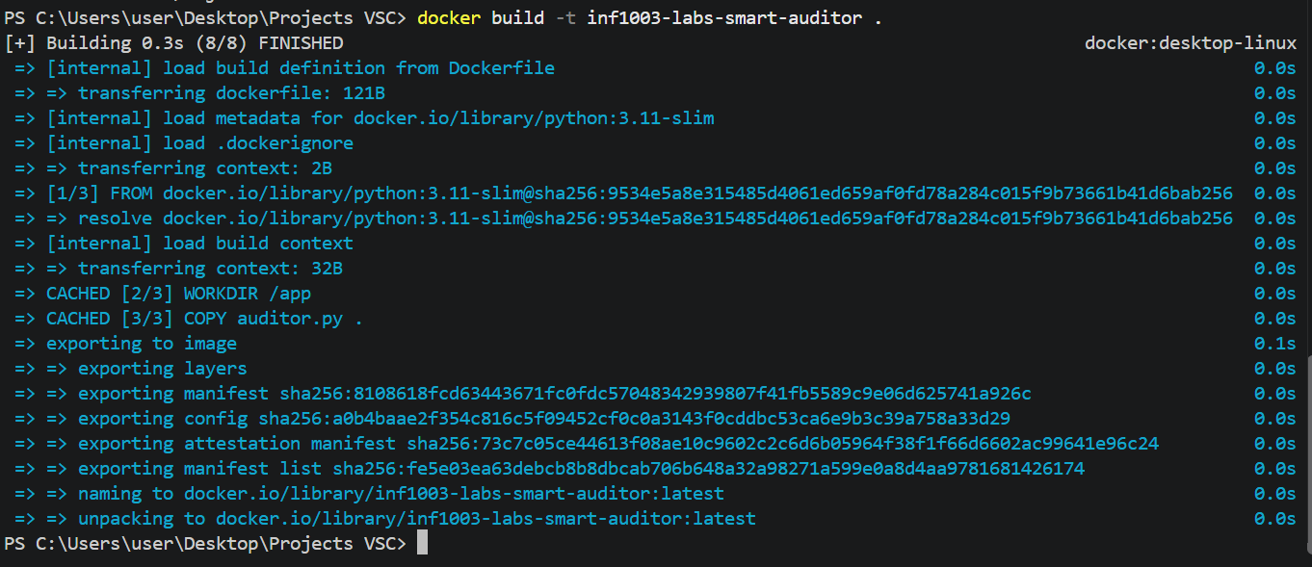

Screenshots – requirement #5 Run the following command for evidence that the image was successfully built.
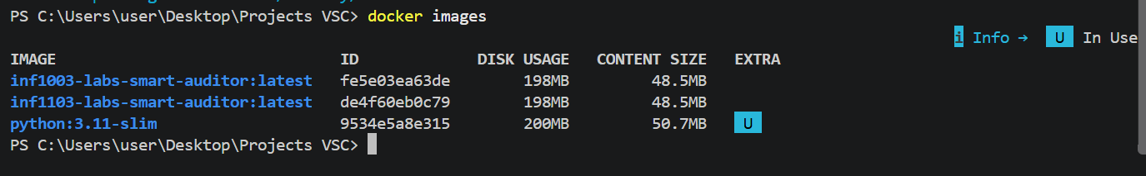

Screenshot - 6. Proof that the custom image runs successfully

